EXP NO: 3
Create a Simple Cloud Software Application for Property Buying & Rental System Using Any Cloud Service Provider to Demonstrate SaaS
Aim
To develop a simple cloud-based Property Buying & Rental System for Chennai City using Zoho Creator, demonstrating the Software as a Service (SaaS) cloud model for managing customer property rental information and automatically calculating the total rental amount.

Procedure
- Log in to Zoho Creator.
- Create a new application named Property Buying & Rental System.
- Create a form and add the following fields:
  - Customer Name
  - Property Type
  - Monthly Rent
  - Months
  - Total Amount
- Configure Total Amount as the output field.
- Add a Deluge script to calculate:
Total Amount = Monthly Rent × Months
- Save the application.
- Run the application in the cloud.
- Enter customer and property details.
- The application calculates and displays the total rental amount automatically.
- Verify the output and save the record.

Implementation
if(input.Monthly_Rent != null && input.Months != null)
{
input.Total_Amount = input.Monthly_Rent * input.Months;)}
info "--------------------------------";
info "PROPERTY BUYING & RENTAL SYSTEM";
info "--------------------------------";
info "Customer Name : " + input.Customer_Name;
info "Property Type : " + input.Property_Type;
info "Monthly Rent : Rs. " + input.Monthly_Rent;
info "Months : " + input.Months;
info "Total Amount : Rs. " + input.Total_Amount;
info "Booking Status : Success";
info "Location : Chennai";
Output
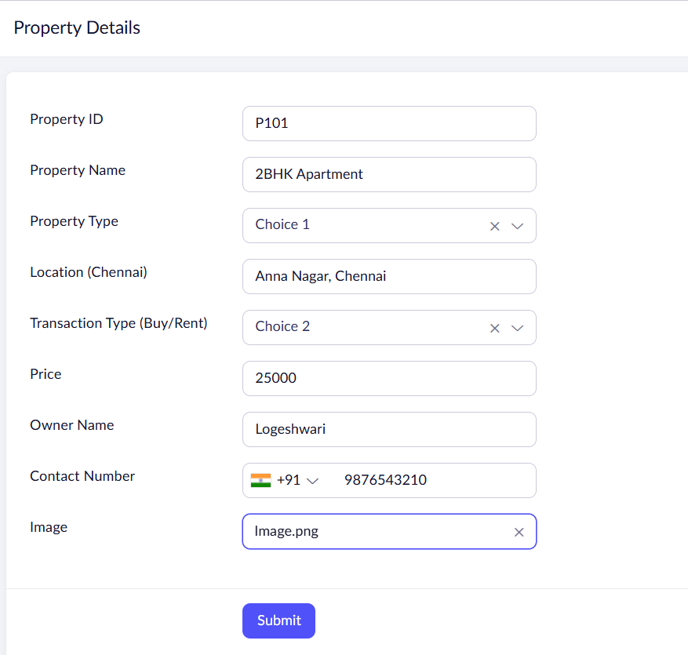
Result
The cloud-based Property Buying & Rental System was successfully created using Zoho Creator (SaaS).

